Anna V. Blake
Student Development
Duquesne University
GILT 515 Instructional Technology

Student Development Overview

This student development will consist of a five-day unit where students will use inquiry-based learning by working on a WebQuest to learn about the American Election process and then take that information to make an iMovie video.
In order for this 5-day lesson to be orchestrated, the teacher must have a MacBook and a projector to present the PowerPoint. Internet must also be available in the building to ensure that the students can access websites throughout the presentation. The students will have access to 1:1 iPads in order to work on the WebQuest. All of these items need to be in place in order to conduct the 5-day unit. In addition to these items, there will be a WebQuest, WebQuest Graphic Organizer, iMovie template and tech skills and cognitive pre-test and post-test.

Objectives, as based on ISTE Standards
This lesson addresses the American election system. At the end of the lesson, the student should be capable of:

I. Use a WebQuest to identify how the American Election system operates
II. Develop an outline for an iMovie about the American Election system
III. Create a 5-7 minute iMovie using the WebQuest information on the election process

ISTE Standards
I. Students demonstrate creative thinking, construct knowledge, and develop innovative products and processes using technology.
- Apply existing knowledge to generate new ideas, products, or processes
II. Students apply digital tools to gather, evaluate, and use information:
- Locate, organize, analyze, evaluate, synthesize, and ethically use information from a variety of sources and media
- Plan strategies to guide inquiry

Lesson One Day One (1 hour)
Introduction (10 minutes)
I. Students complete technology pre-test and pre-cognitive test (See Appendix A&B)
II. Show students the Oregon Trail WebQuest example (See Appendix C)
III. Show the students the “Girl with the Brown Hair” iMovie (See Appendix D)

Practicum and Assessment (40 minutes)
I. Introduce the American Election Process WebQuest
II. Model how to use the American Election Process WebQuest
III. Organize students into groups of three consisting of a scribe, investigator, and materials / technology manager
IV. Student groups work on the WebQuest to fill out the graphic organizer (Appendix E)

Conclusion (5 minutes)
I. Teacher will pass out Exit Ticket (See Appendix F)

Closure (5 minutes)
I. Introduce homework worksheet (See Appendix G)
II. Review task and groups will divide work

Lesson 2 Day 2 (1 Hour)

Introduction (5 minutes)
I. Teacher will review WebQuest structure: introduction, process, task, and evaluation

Practicum and Assessment (45 minutes)
I. Review homework tasks 1, 2, and 3
II. Groups will continue to work on the WebQuest and graphic organizer
III. Teacher will work with students with special needs by implementing text to speech, oral reading, and shortened assignments

Conclusion (5 minutes)
I. Teacher will pass out the Exit Ticket (See Appendix H)

Closing (5 minutes)
I. Introduce homework worksheet (See Appendix I)
II. Teacher will review task and groups will divide work

Lesson 3 Day 3 (1 hour)

Introduction (10 minutes)
I. Each group will present their three main ideas from the three articles in the WebQuest

Practicum and Assessment (40 minutes)
I. Teacher will show the “Girl with Brown Hair” iMovie on YouTube (See Appendix J)
II. Students will watch screencast videos on how to use iMovie (See Appendix K)
III. Students will identify 3 essential tools in iMovie (See Appendix L)
IV. Teacher will distribute Tic-Tac-Toe graphic organizer for students to use and color in after using the iMovie tools (Appendix M)
V. Teacher will review all tools on the graphic organizer

Conclusion (5 minutes)
I. Teacher will pass out the Exit Ticket (See Appendix N)

Closing (5 minutes)
I. Introduce homework worksheet (See Appendix O)
II. Teacher will review task and groups will divide work

Lesson 4 Day 4 (1 Hour)

Introduction (5 minutes)
I. Teacher will review all iMovie tools from the homework sheet

Practicum and Assessment (40 minutes)
I. Teacher will model and introduce the iMovie template (Appendix P)
II. Student groups will complete their template for a 5-7 minute iMovie
III. Groups will present their iMovie templates

Conclusion (5 minutes)
I. Teacher will pass out the Exit Ticket (See Appendix Q)

Closing (10 minutes)
I. Introduce homework worksheet (See Appendix R)
II. Each group will decide who will be the designer, voice narrator, and artist for the final assignment, the iMovie production

Lesson 5 Day 5 (1 Hour)

Introduction (5 minutes)
I. Each group will present on their revised iMovie template from homework

Practicum and Assessment (45 minutes)
I. Teacher will review iMovie tools and show iMovie screencasting video
II. Teacher will show the rubric for grading the iMovie
III. Student groups will create their iMovies using the templates

Conclusion (5 minutes)
I. Student groups will present their work by air playing each iMovie on the whiteboard using the projector

Closing (5 minutes)
I. Teacher will pass out Exit Ticket as a take-home essay (See Appendix S)
II. Students will complete post-cognitive and pre-technology test
(See Appendix T & Appendix U)
Appendix A

Technology Pre-Test

Directions: Answer the questions using complete sentences.

1. What is a hyperlink? How can it be used? (2 pts)

2. What is a WebQuest? (1 pt)

3. What is an iMovie? Name one you have watched. (2 pts)

4. How can you make an iMovie? (1 pt)

5. What tools would you use to make an iMovie? And why? (1 pt)

6. Describe why you would make an iMovie. (1 pt)

Appendix B

Pre-Cognitive Test

1. Describe how in America we elect the president. (2 pts)

2. What are the different steps it takes to become the party’s nominee? (3 pts)

3. What is the Electoral College? (2 pts)

4. What is the importance of voting in day’s world? (3 pts)

Appendix C

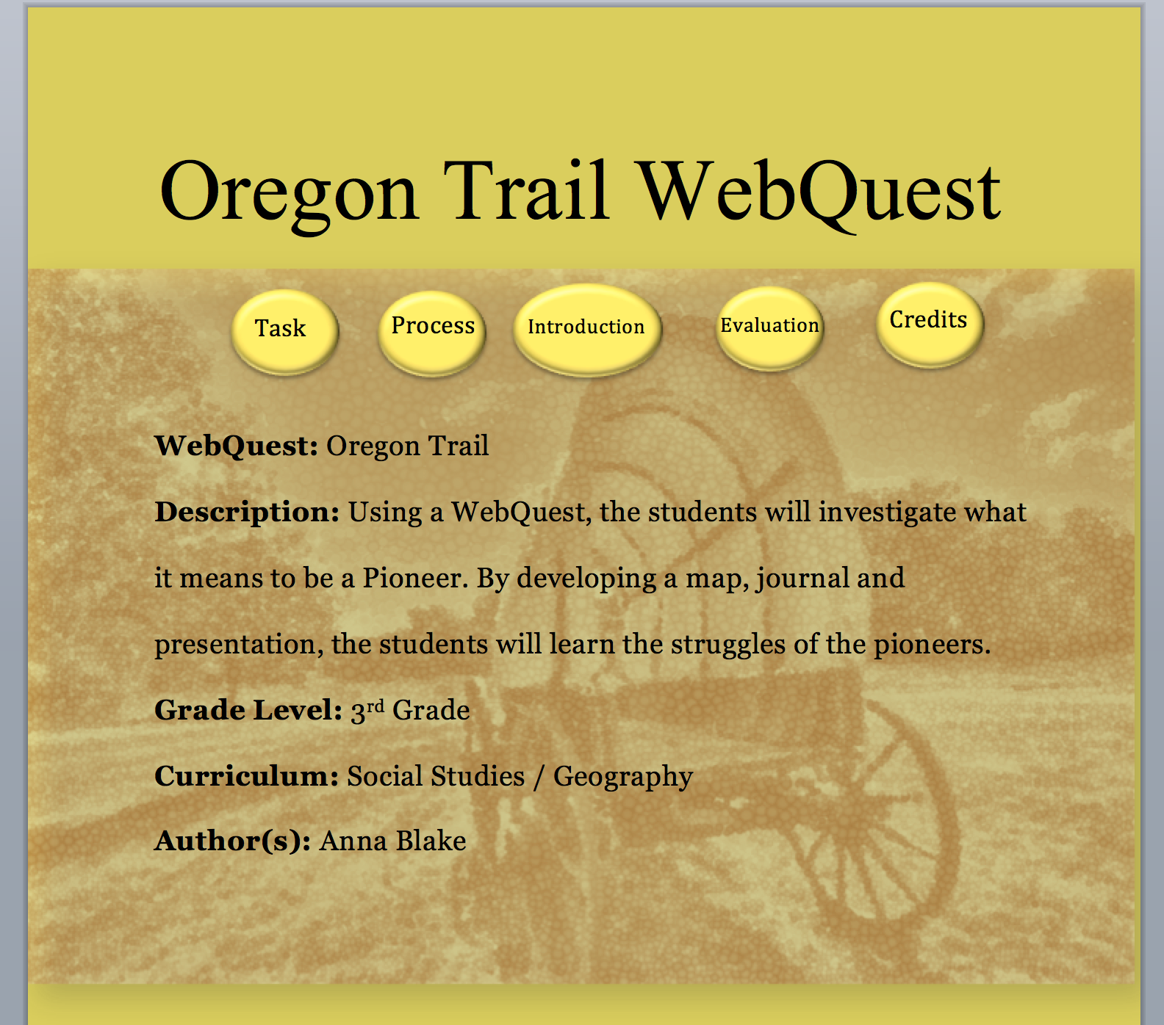

Appendix D

“Girl with the Brown Hair” YouTube Video Link:

https://www.youtube.com/watch?v=CXeKe_xBOD0

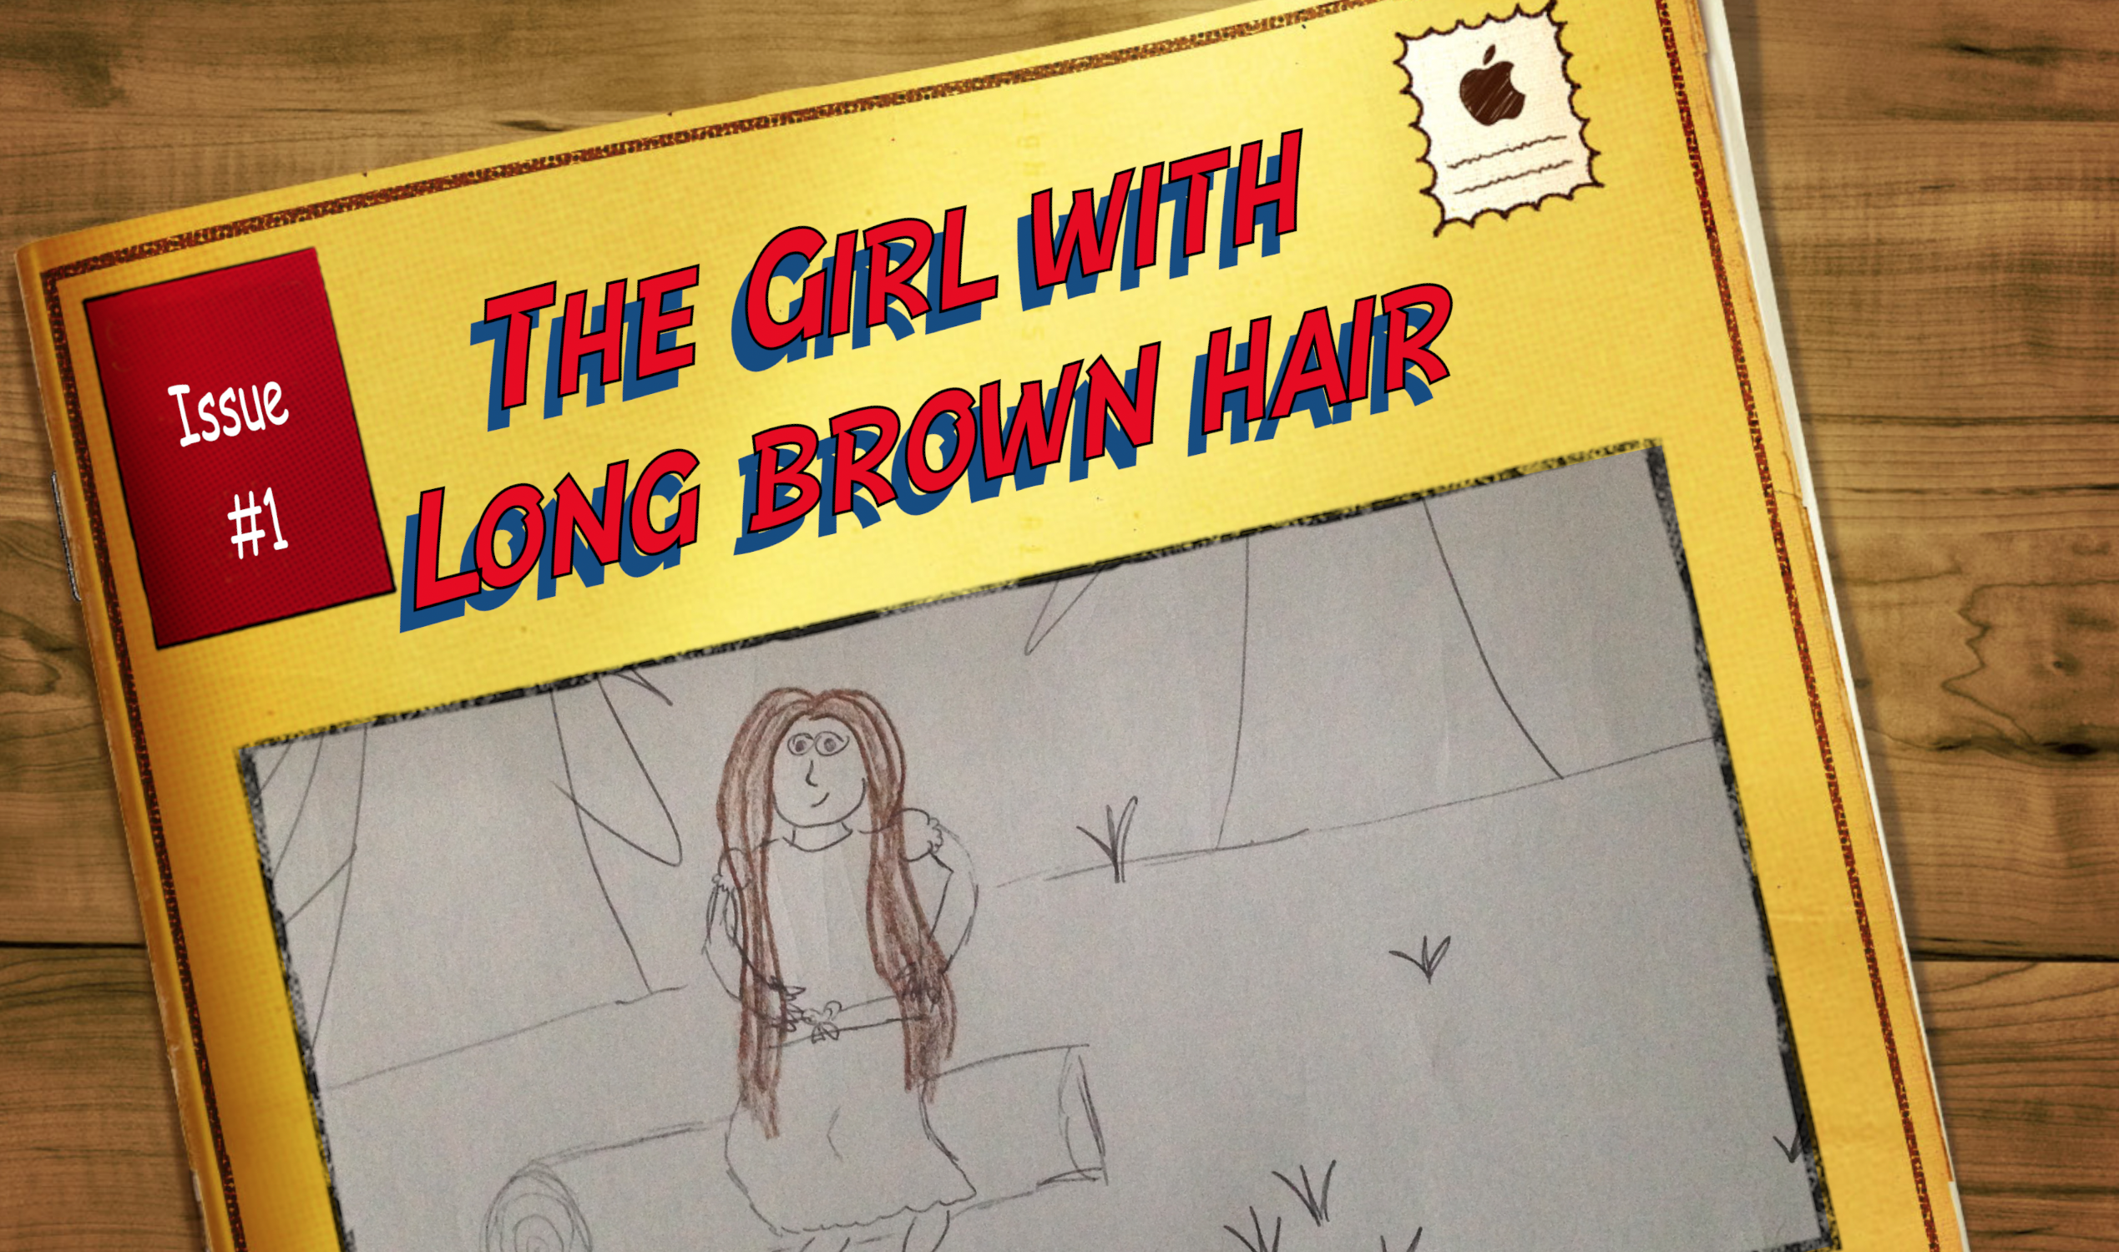

Appendix E

 | Campaign | Ballot Process | Electoral College
Main Idea
Notes
Author’s Purpose

Appendix F

Exit Ticket
Day One

1. How does a hyperlink help you research about the American Election Process?

____________________________________________________________________________________________________________________________________________________________________________________________________________________________________________________________________________________________________________________________________________________________

2. Name one thing you have learned about the American Election Process.

______________________________________________________________________________________________________________________________________________________________________________________________________________________________________________________________________________________________________________________________________________________________________________________________________________________
Appendix G

Homework Assignment
Day One

1. Describe the campaign process.

____________________________________________________________________________________________________________________________________________________________________________________________________________________________________________________________________

2. Name one thing you learned about the election process?

____________________________________________________________________________________________________________________________________________________________________________________________________________________________________________________________________

3. What is a hyperlink?

____________________________________________________________________________________________________________________________________________________________________________________________________________________________________________________________________

Appendix H

Exit Ticket
Day Two

1. Which source was the easiest to use? Why?

____________________________________________________________________________________________________________________________________________________________________________________________________________________________________________________________________________________________________________________________________________________________

2. Name one main idea from one of the sources in the WebQuest.

______________________________________________________________________________________________________________________________________________________________________________________________________________________________________________________________________________________________________________________________________________________________________________________________________________________

Appendix I

Homework Assignment
Day Two

1. If you had to tell a friend about one thing you have learned in the WebQuest, what would it be?

____________________________________________________________________________________________________________________________________________________________________________________________________________________________________________________________________

2. What images would you use to show how America elects its president?

____________________________________________________________________________________________________________________________________________________________________________________________________________________________________________________________________

3. What surprised you about the election process?

____________________________________________________________________________________________________________________________________________________________

Appendix J

The Girl with Brown Hair YouTube video Link:

Appendix K

Screencast YouTube video links:

Introduction to iMovie
https://www.youtube.com/watch?v=GK7JdNdesfA

Inspector in iMovie
https://www.youtube.com/watch?v=_ERUXRdjHG0

Cropping in iMovie
https://www.youtube.com/watch?v=2b2O_KljX_E

Transitioning in iMovie
https://www.youtube.com/watch?v=-_KvcHrbGaI

Sound and Music in iMovie
https://www.youtube.com/watch?v=yEpStnOrsdQ

Advanced Features in iMovie
https://www.youtube.com/watch?v=srWswx1lNY0
Appendix L

 | What the Tool Is Used For? | Why Did You Like It? | What Do You Still Want to Know?
Tool #1
Tool #2
Tool #3

Appendix M

Overview of Tools | Cropping | Transitions | Titles
Sound and Music | Watching screencast video | Importing pictures | Choosing a Template
Adding Music | Hitting ‘Play’ and reviewing | Recording your voice | Adding Sound
Pulling pictures into the script | Adding music to the script | Adding sounds to the script | Overlapping music and pictures

Appendix N

Exit Ticket
Day Three

1. Pick two iMovie tools and tell how to use them on the iPad.

____________________________________________________________________________________________________________________________________________________________________________________________________________________________________________________________________________________________________________________________________________________________
______________________________________________________________________________________________________________________________________________________________________________________________________________________________________________________________________________________________________________________________________________________________________________________________________________________

Appendix O

Homework Assignment
Day Three
1. Find one YouTube video made by a student, and explain what the moviemaker did right.

____________________________________________________________________________________________________________________________________________________________________________________________________________________________________________________________________

2. Find one YouTube video made by a student and explain what the moviemaker did wrong.

____________________________________________________________________________________________________________________________________________________________________________________________________________________________________________________________________

3. What are you most concerned about in making an iMovie?

____________________________________________________________________________________________________________________________________________________________________________________________________________________________________________________________________
Appendix P

Presented by:

Developed by Bernajean Porter

Story Boarding Template Page # __1__

Scene # _1_ VoiceOver Sound / Music Notes

Trans:

Scene # _2_
Trans:

Scene # _3_

Trans:

Story Boarding Template Page # __2__

Scene # _4_ VoiceOver Sound / Music Notes

Trans:

Scene # _5_
Trans:

Scene # _6_
Trans:

Story Boarding Template Page # __3__

Scene # _7_ VoiceOver Sound / Music Notes
.
Trans:

Scene # _8_
Trans:

Scene # _9_
Trans:

Story Boarding Template Page # __4__

Scene # _10_ VoiceOver Sound / Music Notes

Trans:

Scene # _11_
Trans:

Scene # _12_

Trans:

Appendix Q

Appendix Q

Exit Ticket
Day Four

1. Name two ways an outline will help you make an iMovie.

____________________________________________________________________________________________________________________________________________________________________________________________________________________________________________________________________________________________________________________________________________________________
______________________________________________________________________________________________________________________________________________________________________________________________________________________________________________________________________________________________________________________________________________________________________________________________________________________

Appendix R

Presented by:

Developed by Bernajean Porter Job Title : ______________________

Group: _________________________

Story Boarding Template Page # __1__

Scene # _1_ VoiceOver Sound / Music Notes

Trans:

Scene # _2_
Trans:

Scene # _3_

Trans:

Story Boarding Template Page # __2__

Scene # _4_ VoiceOver Sound / Music Notes

Trans:

Scene # _5_
Trans:

Scene # _6_
Trans:

Story Boarding Template Page # __3__

Scene # _7_ VoiceOver Sound / Music Notes
.
Trans:

Scene # _8_
Trans:

Scene # _9_
Trans:

Story Boarding Template Page # __4__

Scene # _10_ VoiceOver Sound / Music Notes

Trans:

Scene # _11_
Trans:

Scene # _12_

Trans:

Appendix Q

Parent Signature _______________________________
Appendix S

Exit Ticket
Day Five

1. Name the best iMovie in the class. Explain your reasons why.

____________________________________________________________________________________________________________________________________________________________________________________________________________________________________________________________________________________________________________________________________________________________
______________________________________________________________________________________________________________________________________________________________________________________________________________________________________________________________________________________________________________________________________________________________________________________________________________________

Appendix T

Post-Technology Test

Directions: Answer the questions using complete sentences.

1. What is a hyperlink? How can it be used? (2 pts)

2. What is a WebQuest? (1 pt)

3. What is an iMovie? Name one you have watched. (2 pts)

4. How can you make an iMovie? (1 pt)

5. What tools would you use to make an iMovie? And why? (1 pt)

6. Describe why you would make an iMovie. (1 pt)

Appendix U

Post-Cognitive Test

1. Describe how in America we elect the president. (2 pts)

2. What are the different steps it takes to become the party’s nominee? (3 pts)

3. What is the Electoral College? (2 pts)

4. What is the importance of voting in day’s world? (3 pts)

