Oregon Trail WebQuest

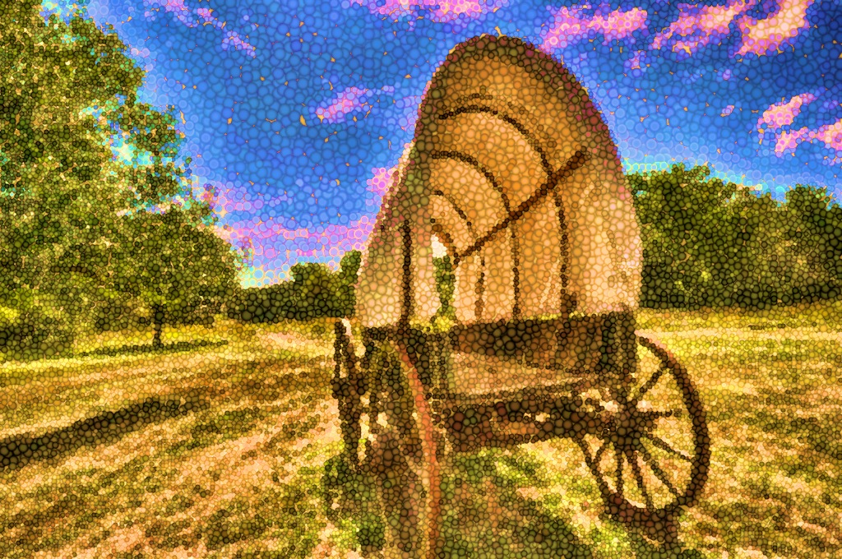

Introduction

Evaluation

Process

Credits

Task

**WebQuest:** Oregon Trail

**Description:** Using a WebQuest, the students will investigate what it means to be a Pioneer. By developing a map, journal and presentation, the students will learn the struggles of the pioneers.

**Grade Level:** 3rd Grade

**Curriculum:** Social Studies / Geography

**Author(s):** Anna Blake



HOME

Come aboard on our journey through the Oregon Trail! Have you ever wondered what it would be like to be a pioneer on the Oregon Trail?

**Now’s your chance class!**

As a **pioneer**, each of you will make your own map showing your classmates your favorite spots in each of the eight states. As you travel on the **Oregon Trail**, you will keep a journal describing what you saw at the thirteen landmarks. After you finish your journey, you will tell the class in a presentation what you found and saw on the **Oregon Trail.**

**Objectives:** Using an online map site, you will mark on your map each of the thirteen landmarks on the Oregon Trail in the first day of the unit.

As you mark your landmarks visited, you will write two sentences about each place. These entries will be considered your travel journal. These entries are due at the end of the week.

Once you’ve completed your map, you will find clothes that represent your journey. On the last day of the unit, you will present one of your favorite landmarks for the entire class. In this presentation, you will act as a pioneer in attitude and dress.

Welcome



**Travelers on your journey on the Oregon Trail you will learn a few things on the way.**

* **You will be able to identify the characteristics of a pioneer.**
* **Identify the Oregon Trail on a map of the U.S.**
* **Describe what you see on your journey through the map and your journal.**
* **Compile thoughts about the journey into a presentation.**

Task

HOME



1. You will be put into groups of four.
2. You will use the map printed out or found here.
3. In your groups, you will log on to the website, <http://www.historyglobe.com/ot/otmap2.htm>
4. On the website, you will as a group go through all thirteen landmarks on the Oregon Trail.
5. Once you click on a landmark, you will mark that landmark on your map of the United States of America.
6. After reading each landmark description with your group, individually you will write two sentences about each of the thirteen landmarks in your notebook.
7. When you complete this activity, you will go home and find clothes that represent pioneers. For pictures click on this website: <http://www.oregonpioneers.com/photoc.htm>
8. As a group of Oregon Trail pioneers, you will give a presentation as to what you found on the digital Oregon Trail.
9. Each member will pick a landmark they liked best and will tell the class about it.

10.Each member of the group will hand in an individual map and thirteen journal entries about the thirteen landmarks.

Process

HOME



Website used was historyglobe.com

The United States map came from america101.us.

The Pioneer pictures came from the website, oregonpioneers.com

Credits

HOME

HOME

|  |  |  |  |  |  |
| --- | --- | --- | --- | --- | --- |
|  | **1** | **2** | **3** | **4** | **Total**  **Points** |
| **Neatness** | **The map, presentation**  **and journal are rushed, illegible, and sloppy.** | **Two assignments look rushed, illegible, and sloppy.** | **One assignment looks rushed, illegible, and sloppy.** | **All assignments are written neatly and are easy to read and understand** |  |
| **Map** | **The student listed less than ¼**  **landmarks correctly.** | **The student listed 1/2 landmarks correctly and Oregon Trail**  **drawn.** | **The student listed 3/4 landmarks correctly and Oregon Trail drawn.** | **The student listed all 13 landmarks correctly and Oregon Trail is drawn.** |  |
| **Content Knowledge**  **(Journal)** | **Student did not demonstrate any knowledge of the topic.** | **Student demonstrated basic knowledge of the topic but did not do the assignments.** | **Student demonstrated basic knowledge of the topic but did not write clearly on the assignments.** | **Student demonstrated through their writing on assignments full knowledge of the topic.** |  |
| **Grammar and Spelling** | **The student’s work has five or more misspelled words and/or grammatical errors.** | **The student’s work has four misspelled words and/or grammatical errors.** | **The student’s work has one or two misspelled words and/or grammatical errors.** | **The student has no misspelled words or grammatical errors.** |  |
| **Presentation** | **The student didn’t speak and didn’t keep eye contact with the class.** | **The student didn’t speak but did keep eye contact with the class.** | **The student did speak but did not keep eye contact with the class.** | **The student both spoke and kept eye contact with the rest of the class.** |  |

Evaluation

**MAP**

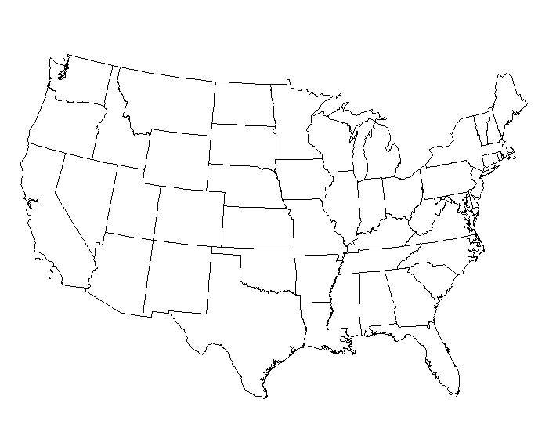

HOME